SUPERSONIC COMBUSTION RAMJET PROPULSION ENGINES

by

Edward J. Efsic III

A Graduate Research Project
Submitted to the Extended Campus
In Partial Fulfillment of the Requirements to the Degree of
Master of Aeronautical Science

Embry-Riddle Aeronautical University
Extended Campus
September 2002
ABSTRACT

Writer: Edward J. Efsic III
Title: Supersonic Combustion Ramjet Propulsion
Institution: Embry-Riddle Aeronautical University
Degree: Master of Aeronautical Science
Year: 2002

NASA and other groups are actively searching for ways to dramatically reduce the cost of lifting objects into earth orbit, currently estimated at approximately $20,000 per kilogram. One of the most promising prospects is the concept of an airbreathing engine capable of propelling an aircraft in the hypersonic (mach 5+) range. A supersonic combustion ramjet, or “scramjet”, theoretically has the capability of reaching orbital velocities. The payload and economy benefits of such an engine become readily apparent when one considers the weight of a typical rocket-based space launch vehicle (like the Space Shuttle) is two thirds oxidizer. The United States and the University of Queensland, Australia, have active scramjet test programs.

TABLE OF CONTENTS
Page
ABSTRACT i
LIST OF FIGURES iii
Chapter
I. The Requirement for A Supersonic Combustion Ramjet 1
II. Basic Design of the Engine 4
III. Advantages of the Supersonic Combustion Ramjet 6
IV. Early Attempts 8
V. Current Projects 12
VI. CONCLUSION 17
REFERENCES 18

LIST OF FIGURES

Figure Page
1 Typical mid-speed airframe-integrated scramjet operation. 4
2 Airbreathing Engine Flight Envelope 6
3 Supersonic combustion research history at LaRC. 8
4 Proposed National Aerospace Plane 9
5 Hyper-X Flight Test Profile 12
6 DFX Location on X-43 13
7 HXEM Location on X-43 13
8 HySHOT Test Profile 16

CHAPTER I
The Requirement for A Supersonic Combustion Ramjet

The goal of any organization whose destination is space is to achieve orbital velocity in its spacecraft for the lowest cost. However, getting a spacecraft to orbital velocity at all is a serious challenge to begin with. The United States Space Shuttle requires acceleration to 17,400 miles per hour for its low earth orbit, 300 km above the earth. This equates approximately to mach 25. So the challenge is to find an economical method of achieving this speed.
Normal turbofan aircraft engines in today’s high performance aircraft have no hope of achieving orbital velocity. In Jane’s All the World’s Aircraft, the listed top speed of the McDonnell Douglas F-15 “Eagle” fighter is only Mach 2.5, while the General Dynamics (now owned by Lockheed Martin) F-16 “Viper” fighter aircraft and the Lockheed Martin F-22 “Advanced Tactical Fighter” are limited to Mach 2. As ambient air enters the turbofan engine, it goes through a compressor stage with various numbers of fan blades. These fan blades compress the air and send it into a combustion chamber, where the fuel is added and explosively burned. The exhaust is directed out the back of the aircraft, producing thrust. At speeds above mach 3, the compressed air reaches such extreme temperatures the compressor stage fan blades begin to fail.
Another type of jet engine doesn’t use any compressor fans, instead relying on the speed of the aircraft and the engine intakes’ geometry to compress the ambient air. This concept lends itself nicely to the name of the engine type, ramjet. However, the basic problem with the ramjet engine is again the extreme temperatures reached compressing and slowing supersonic airflow to subsonic velocities in the engine combustion chamber. To date, the fastest manned aircraft powered by an airbeathing engine is a Lockheed SR-71 “Blackbird”, and it set the speed record at 2,193 mph (Mach 3.2), still hopelessly below orbital velocity. The “Blackbird” aircraft were powered by ramjet engines, and were constructed almost entirely of titanium and titanium alloys (Peacock, 2000).
The U.S. and many foreign nations have thus built their spacecraft and launch vehicles exclusively with rocket engines of various types. Much experimentation has been done with exhaust nacelle shapes, heat dissipation materials, and fuels, but the basic problem all rocket engines share remains. The spacecraft and launch vehicles must carry their own oxidizer along with them. In most cases, this is liquid oxygen (LOX) or a dry chemical oxidizer. In the case of the Space Shuttle, loaded with a maximum payload, the liquid and solid oxidizers account for 64% of the overall liftoff weight of 4.5 million pounds. Similarly, 66% of the 6.5 million pound Saturn V rocket was in the form of liquid oxygen (Damon, 2001).
Rockets have proven their ability regularly throughout the last four decades to achieve, and escape velocity. Their problem lies in cost. Among the most common expendable launch vehicles, the least expensive for lifting objects to is the Long March rocket, costing over $1,600 per pound of payload. Current estimates of overall payload cost for the Space Shuttle is between $7,000 and $8,000 per pound (Hicks, 1997). These costs are in 1994 dollars, so today’s pricetags for a launch into earth orbit is slightly higher. A more recent estimate reflects costs at approximately $20,000 per kilogram (Beardsley, 1999).
There are a several reasons for the high cost associated with launching rockets into low earth orbit. Producing liquid oxygen is a difficult and expensive process. Safely storing it in large quantities, and for extended periods is also an expensive proposition. Valves and hoses of high strength and durability are required to safely and reliably carry the liquid oxygen from storage tanks to the engines in the launch vehicles. Finally, all the extra weight in oxidizer requires much more fuel in a much larger vehicle to escape earths’ gravitational pull. NASA’s Advanced Space Transportation Office Program Manager describes their goal in the Project Plan for Breakthrough Propulsion Physics to “reduce the cost of lifting objects to Low Earth Orbit by a factor of ten by he year 2010… and by an additional factor of ten by the year 2025.” (Millis, 2000)
Some rockets avoid using liquid oxygen as their oxidizer, instead relying on dry chemical reactions for propulsion. For example, the reusable booster rockets on the Space Shuttle use aluminum powder as fuel and ammonium nitrate as oxidizer. These chemicals are often cast and stored in sections, then assembled as required for each launch. One very serious problem with dry chemical rocketry is that the reaction can’t be turned off once it begins.
CHAPTER II
Basic Design of the Engine

The design of scramjet engine is very similar to a basic ramjet engine. The main difference is that the airflow through the engine remains supersonic. To accomplish this, scramjet engines rely heavily on the shape of the entire aircraft. A concept known as “airframe-integrated scramjet” became the standard for most vehicle designs and wind tunnel tests (Rogers, et. al., 1998). The front section of the aircraft is shaped such that the shock waves produced at the aircraft’s leading edges are funneled into the engine. This concept, along with the geometry of the engine inlets, compresses the air for combustion with the fuels.
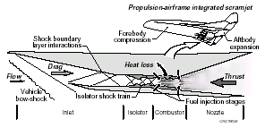
Figure 1. Typical mid-speed airframe-integrated scramjet operation.
Note. From Rogers, R.C., et al., AIAA Paper 98-2506
Like ramjets, scramjets can use hydrocarbon fuels or liquid hydrogen. There is a theoretical upper limit of approximately mach 8 when using hydrocarbons. Above this speed, airflow through the engine is then too fast for the fuel to effectively burn and produce thrust. Liquid hydrogen burns effectively in the combustion chamber at this speed. By engineering fuel flow paths, the liquid or partially frozen “slush” hydrogen has the added benefit of cooling the engine on its way to the combustion chamber.
Once the fuel is ignited in the combustion chamber, the shape of the aircraft again begins to dramatically affect the performance. The shape of the aft section of the aircraft can be engineered to approximate the shape of a partial rocket exhaust nacelle, increasing the engine’s efficiency in producing thrust.

CHAPTER III
Advantages of the Supersonic Combustion Ramjet
There are two main advantages of scramjet propulsion over rocket propulsion for lifting vehicles into orbit. The first major advantage is weight savings. By avoiding the requirement to carry one’s own oxidizer, weight of orbital vehicles can be drastically reduced. This in turn requires drastically less fuel, the end result being a dramatic reduction in overall cost. The second major advantage is maneuverability. Should malfunctions occur during takeoff or ascent, a scramjet-powered aircraft could safely cut its engines and return to its runway.
Estimates vary (between mach 18 and mach 25) with respect to the upper speed limit of a scramjet engine (McClinton, 1999 and Ishmael, 1994). If the scramjet can produce effective (positive) thrust up to mach 25, no other engine would be required to place the vehicle into orbit. If the airbreathing engines can only carry the vehicle to mach 17, then a small rocket will be required to boost the vehicle from mach 17 to orbital velocity. In either case, once in orbit where there is no ambient air, any vehicle will require at least some oxidizer to accomplish a retrofire burn and initiate a deorbit maneuver.
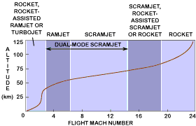
Figure 2. Airbreathing Engine Flight Envelope
Note. Image from NASA Langley Research Center

The second major advantage to the scramjet is the maneuverability added to any mission. Once ignited, solid fuel rockets will burn until their fuel is exhausted. A malfunction on a launch vehicle with solid propellant in almost all cases results in the loss of the vehicle and its payload. The Space Shuttle has the ability to cut its engines and attempt an emergency return to the launch site at Cape Canaveral, or to emergency landing site in southern Europe or northern Africa. As a last resort, NASA could order the ditching of the Shuttle in the Atlantic Ocean. In any of these cases, the external fuel tank and solid rocket boosters would first have to be ejected. A launch vehicle propelled by a scramjet engine could, at any time during ascent, abort its mission and maneuver for return to a suitable landing site.

CHAPTER IV
EARLY ATTEMPTS
Ground Tests
According to Rogers, Capriotti, and Guy, NASA had been conducting research and wind tunnel tests on ramjet, scramjet, and combined engines at Langley Research Center since the 1960’s. The first major project in the field there was called the Hypersonic Research Engine Project, or HRE. Experiments continued on various geometries for inlets, combustion chambers, and exhausts. .
Scramjet test capability has been continually improved at LaRC over the past 40 years… More than 3500 tests were performed, providing about 30 hours of testing, equivalent to about 4 trips around the world at Mach 5. Results from these tests verified scramjet powered vehicle performance and were instrumental in the 1984 initiation of the X-30 Program (McClinton, et. al., 1999).
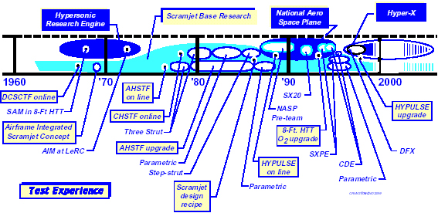
Figure 3. Supersonic combustion research history at LaRC.
Note. From Rogers, R.C., et al., AIAA Paper 98-2506

A Full Scale Flight Vehicle
In 1982, DARPA began a program called Copper Canyon at Langley Research Center, which was a “conceptual phase” to “determine the feasibility of transatmospheric vehicles” (Rumerman, 1999). This was the starting point for the first concerted effort to produce a scramjet aerospace vehicle, the NASA/DOD led X-30 National Aerospace Plane (NASP) project. The Department of Defense, led by the Air Force was responsible for management of the overall program, and would assume 80% of the costs. NASA would supply the other 20%.
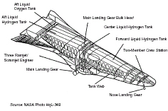
Figure 4. Proposed National Aerospace Plane
Announced in January 1986, the goal was to produce a prototype aerospace vehicle embodying two main concepts, “HOTOL” and “SSTO”. “HOTOL” stands for horizontal takeoff and landing, like a normal airplane, and “SSTO” stands for single-stage-to-orbit. No engine or rocket stage would separate from the vehicle as it made its way into orbit. This vehicle would also have to be easily prepared for launch. McDonnell Douglas and Rockwell International were responsible for the airframe, while Pratt & Whitney and Rocketdyne were going to produce the propulsion system. Technology leaps were required in several fields, such as materials, computational fluid dynamics, integrated control system, and aerodynamics. While it would represent a tremendous leap in our ability to go to space, the X-30 was designed only as a test vehicle to explore new technologies, not as a production line aerospace vehicle (Ishmael, 1989).
The 150 to 200 foot long airframe of the X-30 was based on the lifting body concept, where the shape of the vehicle’s body would provide most of the lift. There would be only small wings and no rear vertical stabilizer, which would have added significantly to the vehicle’s drag. At takeoff, the NASP was planned to weigh between 125 and 150 tons. New materials were developed for the airframe, such as an advanced carbon-carbon composite material for use NASP control surfaces (Baer-Riedhart, 2001). This material would be stronger than metal at high temperatures, and lighter than aluminum.
The heart of the X-30 was its airframe-integrated dual-mode ramjet/scramjet propulsion system, and the main technical challenge. There were three main facilities to test the prospective engines, and all three wind tunnels used heat to accelerate air before entering the test chamber. The first facility, the Arc-Heated Scramjet Test Facility (AHSTF), used an electric arc to heat air. That air was then mixed with unheated air for the wind tunnel. Another test facility was the Combustion-Heated Scramjet Test Facility, and it burned hydrogen for its heat. The technicians then added oxygen to get the required chemical ratio (21% O₂) for the wind tunnel. The last engine test facility was the newly upgraded, 8-Foot High Temperature Tunnel. It was then capable of adding oxygen to its airflow, having been previously heated by burning methane (Rogers, et.al., 1998). The AIAA paper 98-2506, by Rogers, Capriotti, and Guy, provides an excellent summary of the test facilities and all the engines/engine components tested.
Between 1984 and 1995 the NASP Program spent over three billion dollars, but as early as 1988 budget issues became a serious concern. By then the NASP Program was a year behind schedule, and the first scheduled flight was postponed until at least 1994. NASA had other problems to deal with besides the NASP Program budget woes. They were trying to get the Space Shuttle Program restarted after the Challenger disaster, and the International Space Station also required heavy funding. In 1993, the DOD discontinued funding for the NASP, and the 1994 federal budget only allotted $80 million to the program. All NASP funding was discontinued in 1995 (Rumerman, 1999). No full scale NASP aircraft was manufactured.
Despite the cancellation of the program, the money spent on the X-30 project paid huge dividends in all the scientific fields the NASP Program was intended to pursue. New high strength, lightweight, and corrosion resistant materials were developed. New methods of investigating computational fluid dynamics were developed, along with high speed, high temperature instrumentation and flight controls.
Subscale models
Following the cancellation of the NASP Program, NASA and others recognized the need to continue scientific research on hypersonic engines. They also realized small scale aircraft could be modeled to test the hypersonic engines, and save billions of dollars (Freeman, et.al., 1997). Prior to the NASP shutdown in 1995, NASA began experiments in what was called the “Waverider” projects. Instead of building manned aircraft to flight test hypersonic engines, they would contract for sub-scale models.
The first of these was called LoFLYTE, for Low Observable Flight Test Experiment. It was designed to test flight conditions at very low speeds (approximately 250 knots). It had a small gas turbine engine for inflight propulsion. The scramjet configuration would be tested unpowered in the wind tunnels at speeds up to Mach 5.5. On its second flight it suffered damage in a gear up landing, but was repaired and flew ten more missions (Peacock, 2000).

CHAPTER V
CURRENT PROJECTS
The “Hyper-X” X-43
In February, 1995, McDonnell Douglas began a conceptual design for a subscale model to perform flight testing at medium hypersonic speed. They completed the design in May, 1995, and began accepting bids to manufacture the 12 foot long, 5 foot wide Flight Research Vehicles (NASA News Release, 1996). According to Jane’s 2000-2001, the Phantom Works was an unsuccessful bidder, losing out to Microcraft Inc., of Tullahoma, TN. Microcraft was to build the four small, unmanned, and expendable “Hyper-X”, X-43 vehicles. The Hyper-X vehicles were almost entirely photographically scaled from the NASP, with the notable exception of the scramjet flowpath. The scramjet flowpath was “reoptimized for engine operability and vehicle acceleration, accounting for scale, wall temperature effects, etc.” (Freeman, et. al., 1997). Accurate Automation Corp. of Chattanooga, TN, which previously worked with the NASP Program, would manufacture the instrumentation for the X-43.
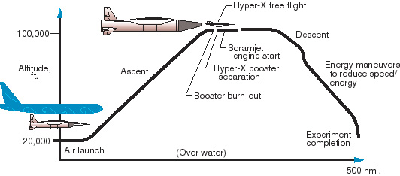
Figure 5. Hyper-X Flight Test Profile
Note. From NASA Langley Research Center Web Site
Since the ramjet/scramjet engine could not power itself to the engine operating speeds, the plan for flight-testing was to attach the Hyper-X aircraft to a rocket powered launch vehicle, and air launch the “stack” from underneath a B-52 wing. The rocket powered launch vehicle was the Pegasus rocket, developed and built by Orbital Sciences Corporation Launch Systems Group. However, the Pegasus rockets to be used by the Hyper-X program was heavily modified. Initially a three-stage launch system, the second and third stages was removed, leaving only an Orion 50S solid rocket motor. The payload fairing normally used to protect satellites was replaced with a ballast assembly and payload adapter for the Hyper-X vehicle to be mounted in front. Furthermore, since the assembly would spend all its time in the atmosphere, a new thermal protection system was added to protect the booster’s composite structures (Orbital, 2002).
As was the case with the NASP dual mode engines, the Hyper-X engines underwent extensive testing on the ground. Most tests were conducted on a portion of the aircraft called the DFX, or “dual fuel experimental” engine, although NASA technicians at Langley Research Center conducted full-scale tests using the 8-foot High Temperature Tunnel facility (Hicks, 1997). The DFX was later replaced by the HXEM “Hyper-X Engine Module”, which reduced the width by moving in the sidewalls but maintained all other features. Plans then were to conduct the first flight at Mach 7 early in 2000.

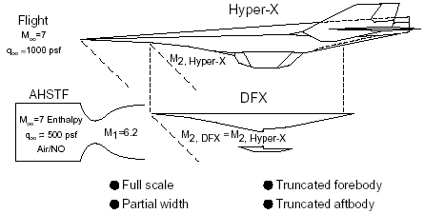
Figure 6. DFX Location on X-43
Note. From LaRC Web site
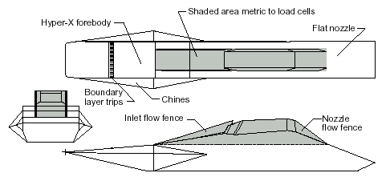
Figure7. HXEM Location on X-43
Note. From LaRC Web site

The first actual flight of a completed X-43 was on June 2, 2001 at 24,000 feet over the Pacific Ocean. Several captive flights had already been conducted, where the Pegasus/ Hyper-X stack was mounted for takeoffs and landings. The stack was released at 1:43 p.m. and the Pegasus ignited. Approximately 8 seconds after that ignition, the Pegasus rocket began to go out of control (later determined to be on account of structural failure), and the test director ordered the vehicles be destroyed by explosive charge. The debris from the launch vehicle and the research vehicle fell into the Pacific Ocean, and the B-52 returned to Edwards AFB undamaged (Baer-Riedhart, 2001). Robert W. Hughes was appointed Chairman of the investigation board. In a News Release on August 16, 2001, the NASA Public Affairs Office reported a list of several hundred possible causes had been made, and 85% of the possible causes closed. Most of the remaining possible causes were with the Pegasus launch vehicle control, and were being evaluated.
"The NASA team, to include the Mishap Investigation Board, have been conducting numerous reviews, wind tunnel testing and other tests to mitigate risk for the second flight. If all goes as expected, the plan is to fly the second vehicle next summer. The mishap report will likely be released this fall by NASA Headquarters. At that time, a news release will be issued with a web link to the full report." (Baer-Riedhart, 2002).
HySHOT, Austalia’s Answer
While the Hyper-X program was underway, another group was working on a scramjet flight test. Allan Paull was heading a team at the Centre for Hypersonics from the University of Queensland, Australia. NASA, Australian Industry and Defense Departments, and foreign government agencies from the United Kingdom, Germany, South Korea, and Japan provided partial sponsorship. Their plan was a vertical launch of a two-stage rocket, where the actual scramjet motor would ignite and be tested during the descent. The fuel for the HySHOT was gaseous hydrogen (UQ, 2001).
The first stage of the rocket was a Terrier rocket motor, accelerating the assembly to 4000 km/hr in the first 6 seconds. Once the Terrier motor is jettisoned, the second stage, (an Orion motor) ignites and accelerates the assembly to 8300 km/hr at an altitude 56 km. The Orion motor is not jettisoned during the experiment, and when the assembly leaves the earth’s atmosphere a cold gas discharge ejects the nosecone. The assembly then reorients itself above the earth’s atmosphere for the return to earth. Since the assembly was rotating at approximately 6 revolutions per second, the reorientation presented some unique challenges to turning the rocket at the top of its trajectory. The HySHOT team solved this with what they called the “Big Bang” maneuver. By applying an impulse to he spinning object, they cause it to begin to nutate. Another impulse stops the nutation after 180 degrees, and effectively changes the angular position of the object. During its flight, the HySHOT system undergoes approximately 50 of these maneuvers to get it into its position for the descending test (UQ, 2001).
At its apogee, the assembly is traveling at Mach 2.7, 314 km above the earth. It completes its reorientation during the descent back to the earth’s atmosphere. The scramjet combustion experiment only lasts for 5 to 6 seconds from 35 km to 23 km in altitude, and notably does not provide positive (accelerating) thrust. It was designed to measure pressure in the combustion chamber and on the thrust surface for comparison and validation of ground test data (UQ, 2001).
Ground testing of the HySHOT equipment was conducted to ensure the test equipment could withstand the initial acceleration of the rocket, 20 times the force of gravity. A rig was built to provide vibrations, and individual components and combinations of components were tested. Computer software was evaluated using a three-axis gimbal because the experiment was designed to rotate inflight.
The first launch of the HyShOT was October 23, 2001, and it was unsuccessful in demonstrating hypersonic combustion. The second launch was less than a year later. On July 30, 2002, the HySHOT was launched from the Woomera Test Range by the Australian Department of Defense. That launch successfully demonstrated scramjet combustion in flight at Mach 7.6 (David, 2002).
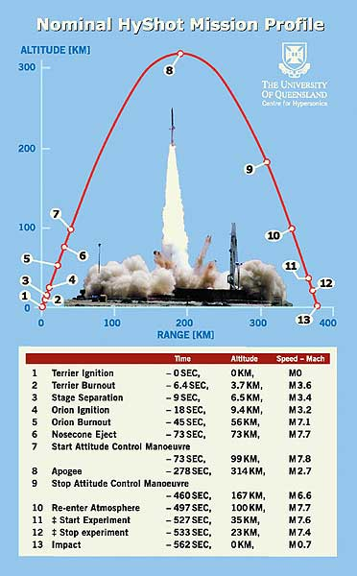
Figure 8. HySHOT Test Profile
Note. From Centre for Hypersonics, University of Queensland

CHAPTER VI
CONCLUSION

Mankind has an innate drive to leave behind safe places, search out, and explore unknown places. That we, as a species, could or should leave the planet earth in search of other places to live is irrelevant because it’s inevitable. To seek and explore the solar system, galaxy, and universe is in our very nature. Now that we have the technology to leave the gravity well we call Earth, we found it incredibly expensive to do so. NASA’s search to reduce the costs of lifting mass to orbit by an order of magnitude before the year 2010 could be fully realized with scramjet technology. The success of the HySHOT Program and the second planned test of the Hyper-X will be the stepping stones of future technologies.
As to NASA’s goal of reducing costs another order of magnitude by 2025, that will probably not be realized by scramjet technology. Perhaps the Breakthrough Propulsion Physics Project can show us something, or more likely, some independent scientist (whom generations to come might label “the father of space flight”) will come up with a method to revolutionize space travel. My money’s on the particle physicists and their production/containment of antimatter or gravitons.

REFERENCES
Baer-Riedhart, Jenny (December 27, 2001). X-Planes Overview, Retrieved September 16, 2002, from NASA Dryden Flight Research Center Web site: http://www.dfrc.nasa.gov/History/x-planes.html
Baer-Riedhart, Jenny (August 23, 2001). Hyper-X, Retrieved September 19, 2002, from NASA Dryden Flight Research Center Web site: http://www.dfrc.nasa.gov/Projects/hyperx/developments.html
Baer-Riedhart, Jenny (September 2002). Dryden Research Update X43A, Retrieved September 19, 2002, from NASA Dryden Flight Research Center Web site: http://www.dfrc.nasa.gov/PAO/X-Press/update/x43a.html
Beardsley, Tim (1999). The Way to Go in Space, Scientific American, Feb1999, Vol. 280 Issue 2
Damon, Thomas D. (2001). Introduction to Space, The Science of Spaceflight (3rd ed.). Malabar, FL: Krieger
David, Leonard (2002). Results Just In: HyShot Scramjet Test a Success, Space.com, Retrieved September 16, 2002 from http://www.space.com/missionlaunches/hyshot_020816.html
Freeman, Delma C., Reubush, David E., McClinton, Charles R., Rausch, Vincent L., and Crawford, J. Larry (1997). The NASA Hyper-X Program, 48th International Astronautical Congress, Turin, Italy, Retrieved September 16, 2002 from NASA Langley Research Center Web site
http://hapb-www.larc.nasa.gov/Public/Doucuments/NASA-97-48iac-dcf.pdf
Hicks, John W. and Trippenese, Gary (1997). NASA Hypersonic Plane Flight Development of Technologies and capabilities for the 21st Century Access to Space, Paris, France
Ishmael, Stephen D. (1989). What is the X-30, Proceedings of the X-15 First Flight 30th Anniversary Celebration, Retrieved September 16, 2002 from http://www.hq.nasa.gov/office/pao/History/x15conf/what.html
McClinton, C.R., Hunt, J.L., Ricketts, R.H., Ruekauf, P., and Peddie, C.L. (1999). AIAA Paper 99-4978 Airbreathing Hypersonic Technology Vision Vehicles and Development Dreams,
McClinton, Charles R. (1999). Air-Breathing Engines, Scientific American, Feb1999, Vol. 280 Issue 2
Millis, Marc G. (2000). Project Plan for Breakthrough Propulsion Physics, Cleveland, OH, Glenn Research Center
NASA News Release 96-10-09 (9 October 96). NASA Seeks Hyper-X Proposals, Retrieved September 29, 2002 from NASA Web site: http://spacelink.nasa.gov/NASA.News/NASA.News.Releases/Previous.News.Releases/96.News.Releases/96-10.News.Releases/96-10-09.NASA.Seeks.Hyper-X.Proposals
NASA News Release 01-43a (18 June 2001). X-43A MISHAP INVESTIGATION UPDATE, Retrieved September 19, 2002 from Langley Research Center Web site:
http://oea.larc.nasa.gov/news_rels/2001/01-043a.html
NASA News Release 01-60 (16 August 2001). X-43A MISHAP INVESTIGATION UPDATE, Retrieved September 19, 2002 from Dryden Flight Research Center Web site: http://www.dfrc.nasa.gov/PAO/PressReleases/2001/01-60.html
Orbital Sciences Corporation (2002). Hyper-X, Retrieved August 29, 2002 from Orbital Sciences Corporation Web site: http://www.orbital.caom/LaunchVehicles/Hyper-X/
Peacock, Lindsay (2000). Jane’s All the World’s Aircraft, Coulsdon, Surrey, UK: Sentinel House
Rogers, R.C., Caproitti, D.P., and Guy R.W (1998). AIAA Paper 98-2506 Experimental Supersonic Combustion research at NASA Langley, Hampton, VA
Rumerman, Judy A. (1999). NASA Historical Data Book (SP-4012) Vol. VI, Chap. 3, Washington: NASA, Retrieved September 16, 2002 from NASA Web site: http://history.nasa.gov/SP-4012/vol6/cover6.html
University of Queensland (2001). HyShot, A University of Queensland Initiative, Retrieved September 16, 2002 from University of Queensland Centre for Hypersonics Web site: http://www.mech.uq.edu.au/hyper/hyshot/

